Add a Patient -Capture

Functionality: This dialogue should allow user to capture new patient for Main Org. It should allow the user to add all necessary information to handle billing and contact information as well as capture information that might be tracked by the user. The current information requested on current Add-a-Patient dialogue, in Physia, handles the majority of information but does need some modification. The first items to be discussed are the fields themselves and then the action keys (look up and adds) will be discussed in a following document.

Information captured in Dialogue

See below:
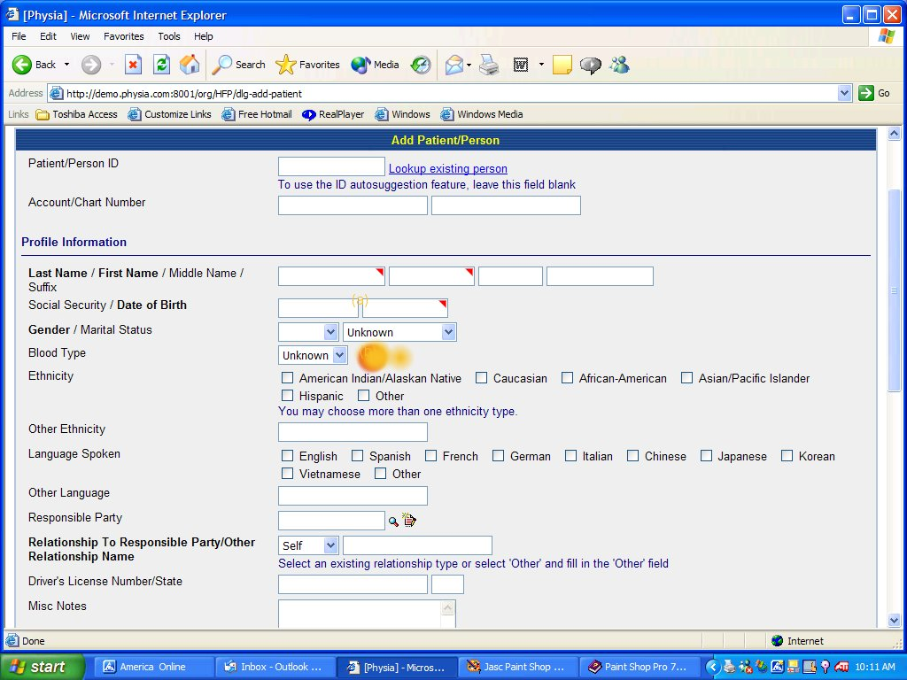Fig 1a

Add:
- Add identification that Gender is a required field (In Physia the required field identifier was a red triangle.) See (a).
- Prefix field (See add-a-patient in Medspective) This allows user to add Mr., Ms., or Mrs.
Remove:
- Blood type. (See orange splotch)

Additional Remarks about Add-a-patient
- Person ID is at the beginning of dialogue and has a look up feature. (See next document for treatment of action codes.)
- Account/Chart number availability.
- Spaces for names are labeled. (Last Name/First Name/Middle Name/Suffix)
- SSN can be entered with different formats (xxx-xx-xxxx, xxxxxxxxx, xxx.xxx.xxx) and the application will do the conversion to xxx-xx-xxxx.

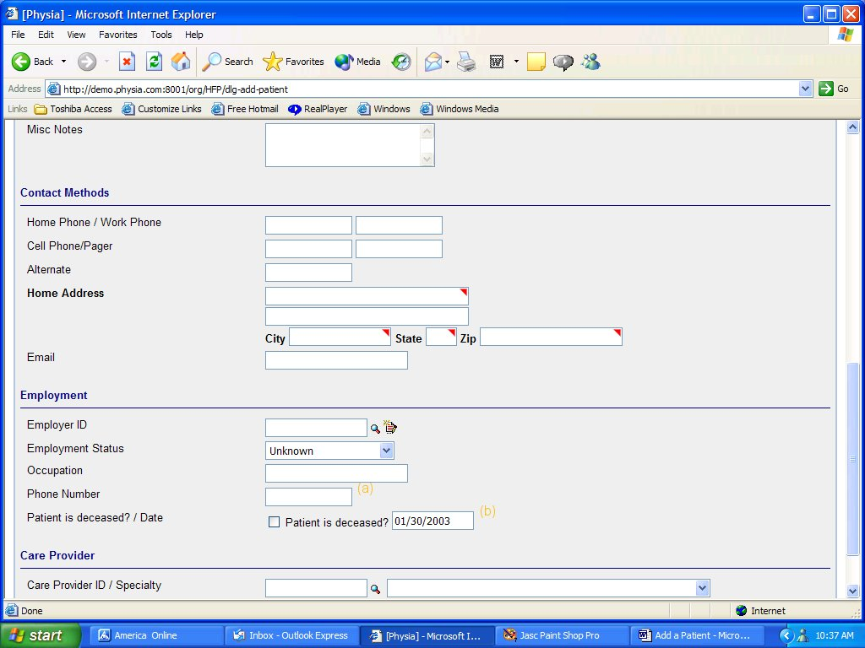
Fig 1b

Add:
- Add “Return to Previous Screen” to the Next action drop down.

Remove:
- Remove phone number from the employment area- it is redundant and is one more tab the user has to do.
- Remove Patient is deceased. This is an item that can be added to summary page after completion. (This will be discussed in a different document) The majority of the time, a new patient won’t be dead.
Additional Remarks about this page:
1) There is a space for the most commons numbers as oppose to a drop down add in (like the one used in add licensures for physicians) this allows the user to flow through tabs without having to choose what type of number. If the user needs to add another number not mentioned on this dialogue- they may do it through add/edit in the summary page. (To be discussed later). Each tab is labeled, according to the space (Home Phone/Work Phone) then the spaces next to them.
  - Free text for Misc notes.
  - Home address has the red triangles indicating they are required.
  - Ability to do a look up for Employer ID. (The section on Employment in Medspective has the necessary fields and only needs a look up for an existing Employer ID-see next document on action codes)

